**APPLIED SCIENCE AND HUMANITIES LABORATORIES**

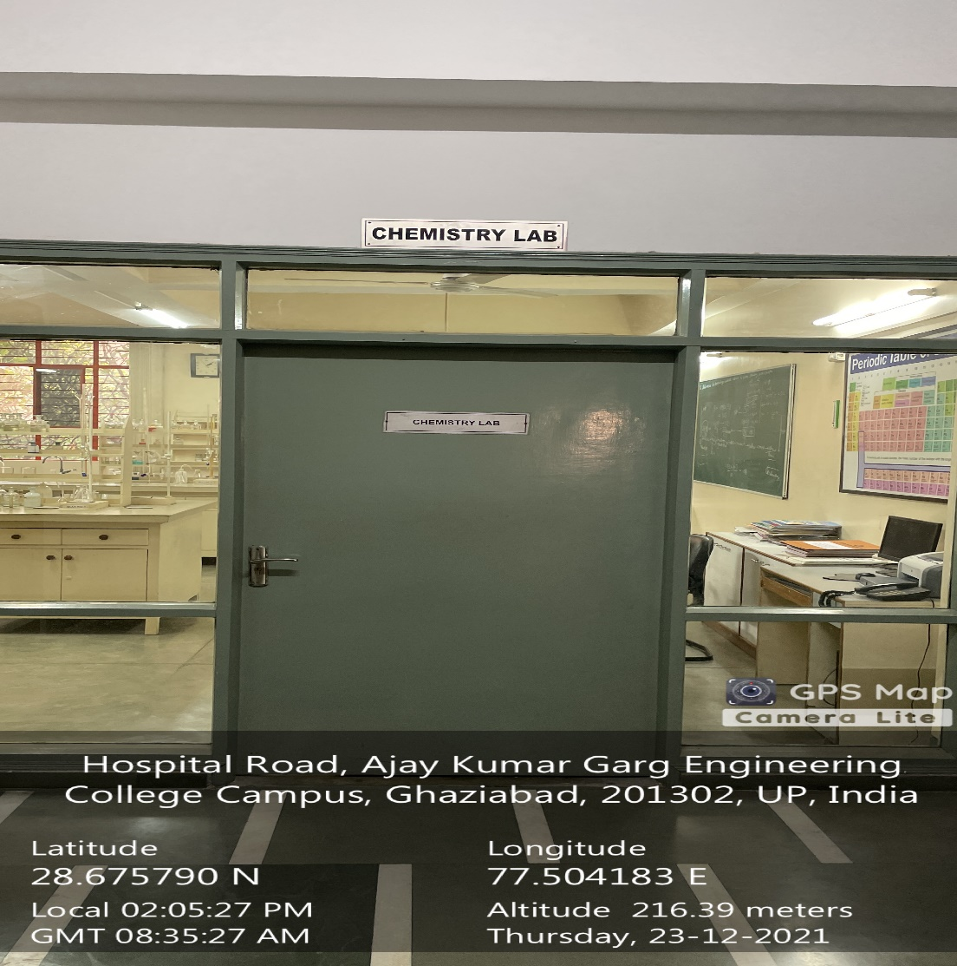

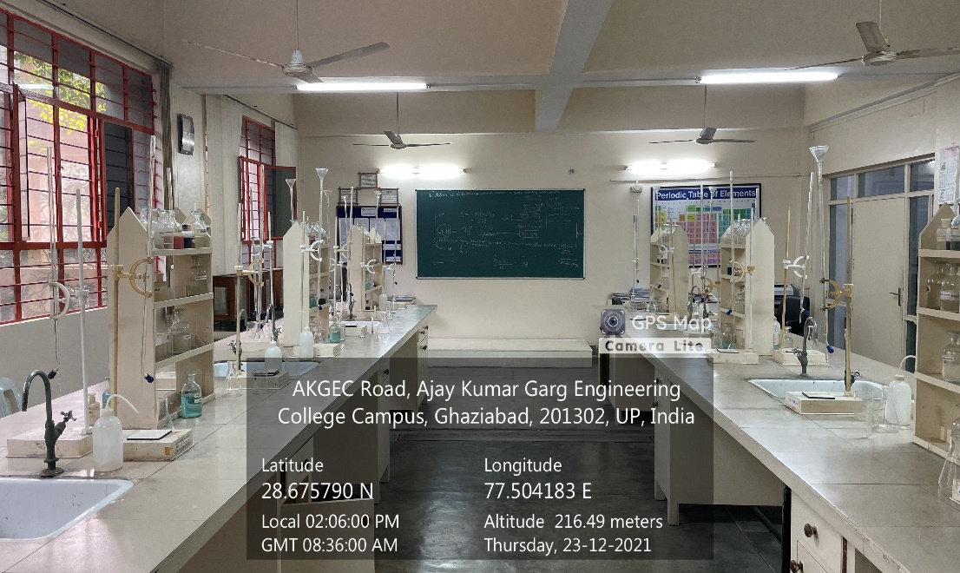

**ADMINISTRATIVE BLOCK GROUND FLOOR, CHEMISTRY LAB**

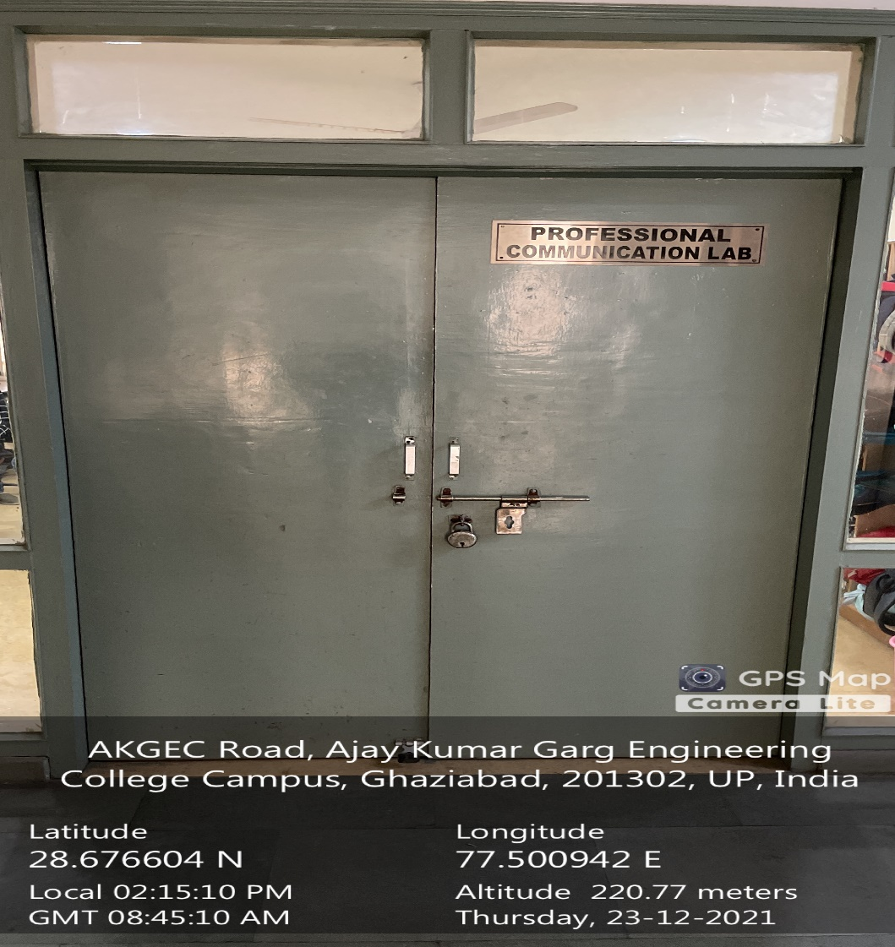

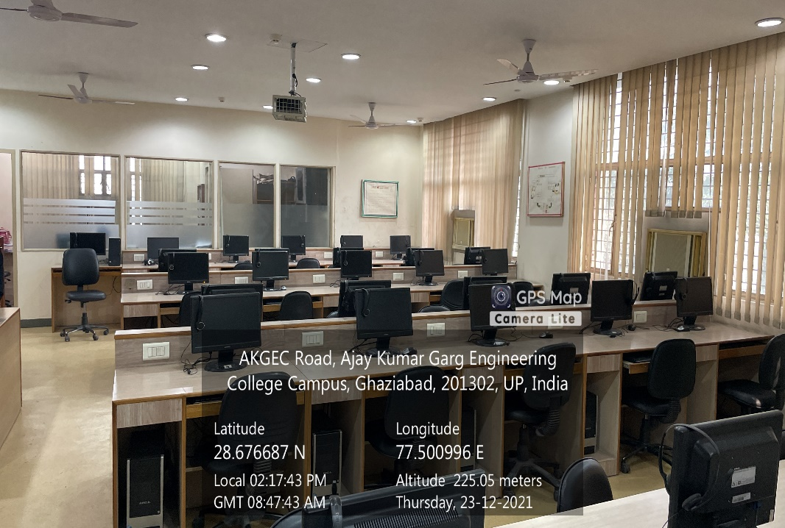

**ADMINISTRATIVE BLOCK GROUND FLOOR, ENGLISH LANGUAGE LAB**

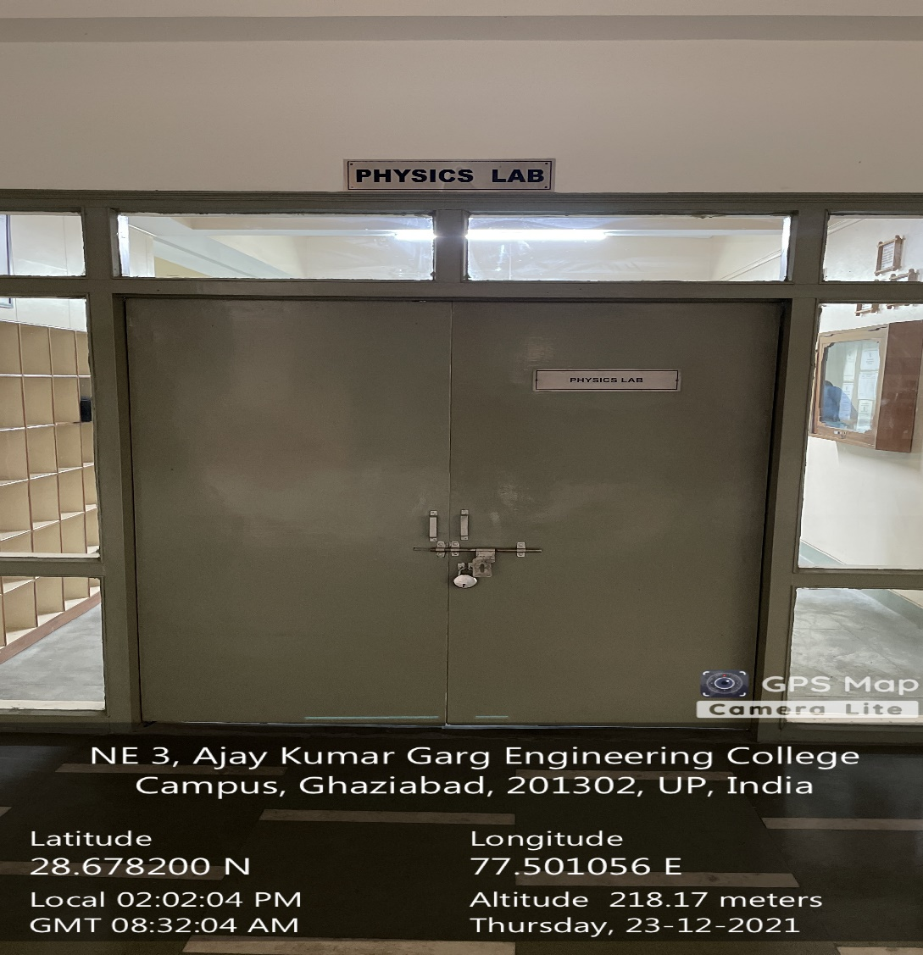

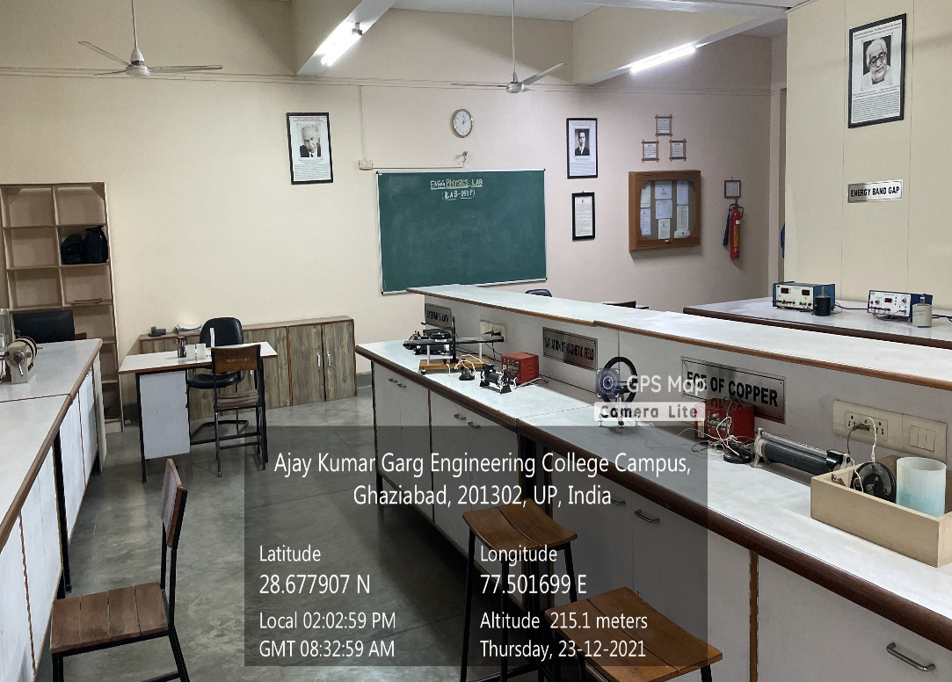

**ADMINISTRATIVE BLOCK GROUND FLOOR, PHYSICS LAB**